**Structured Query Language**

Assignment 1

Create Northwind Database and sample table products :-

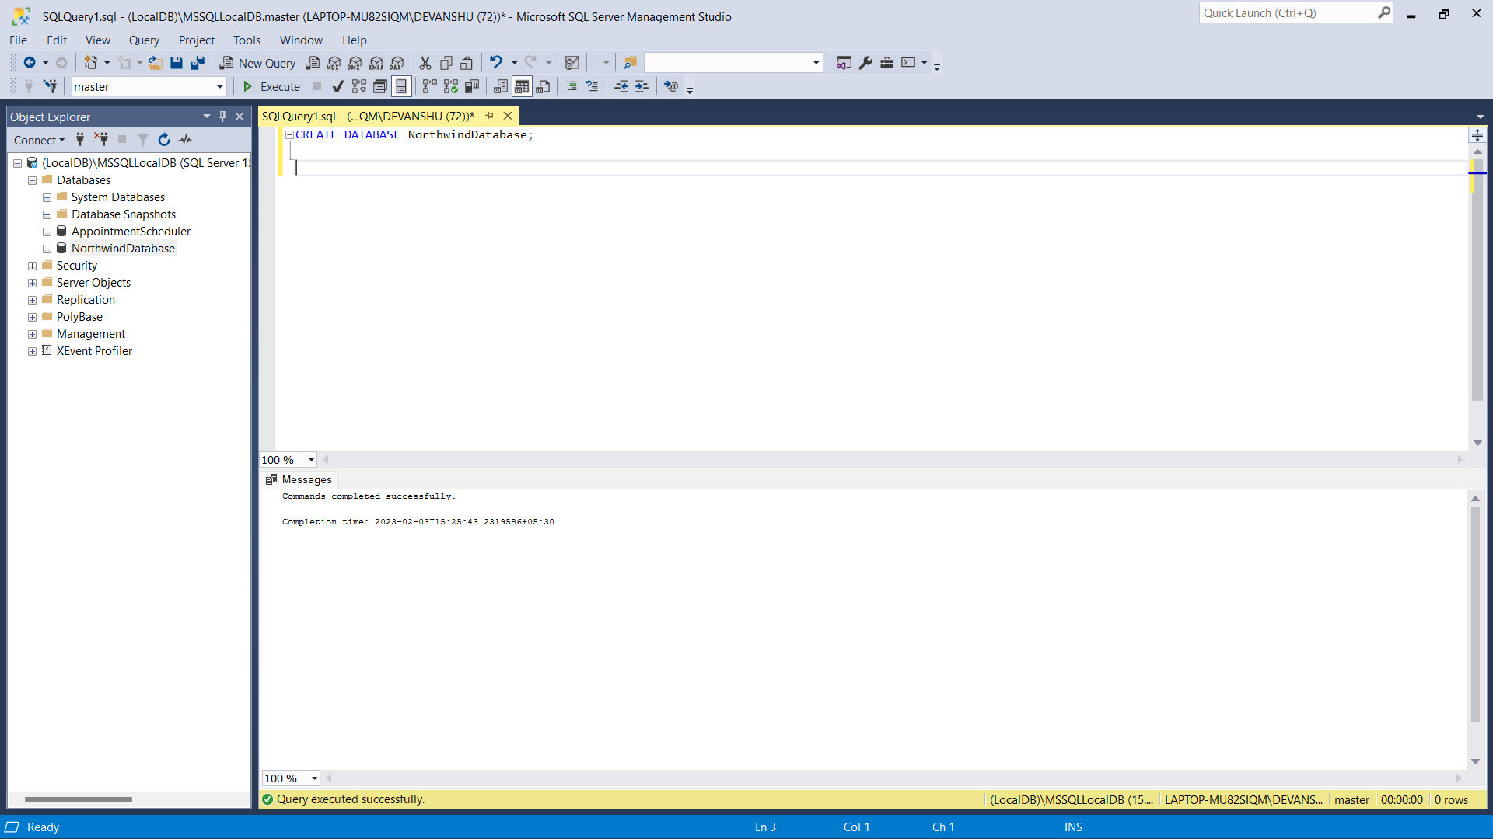

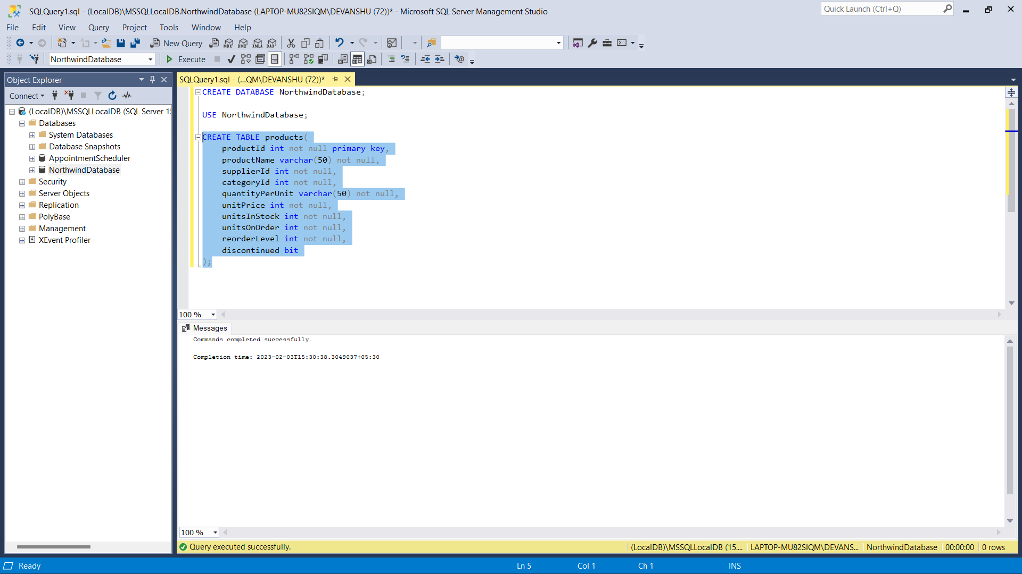

Inserted values in table :-

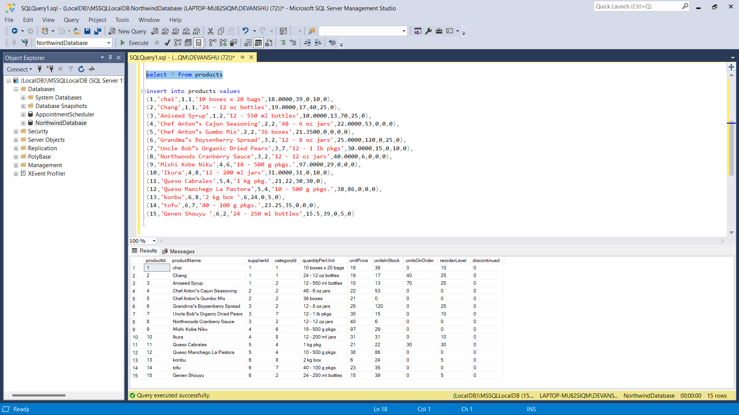

1. Write a query to get a Product list (id, name, unit price) where current products cost less than $20.

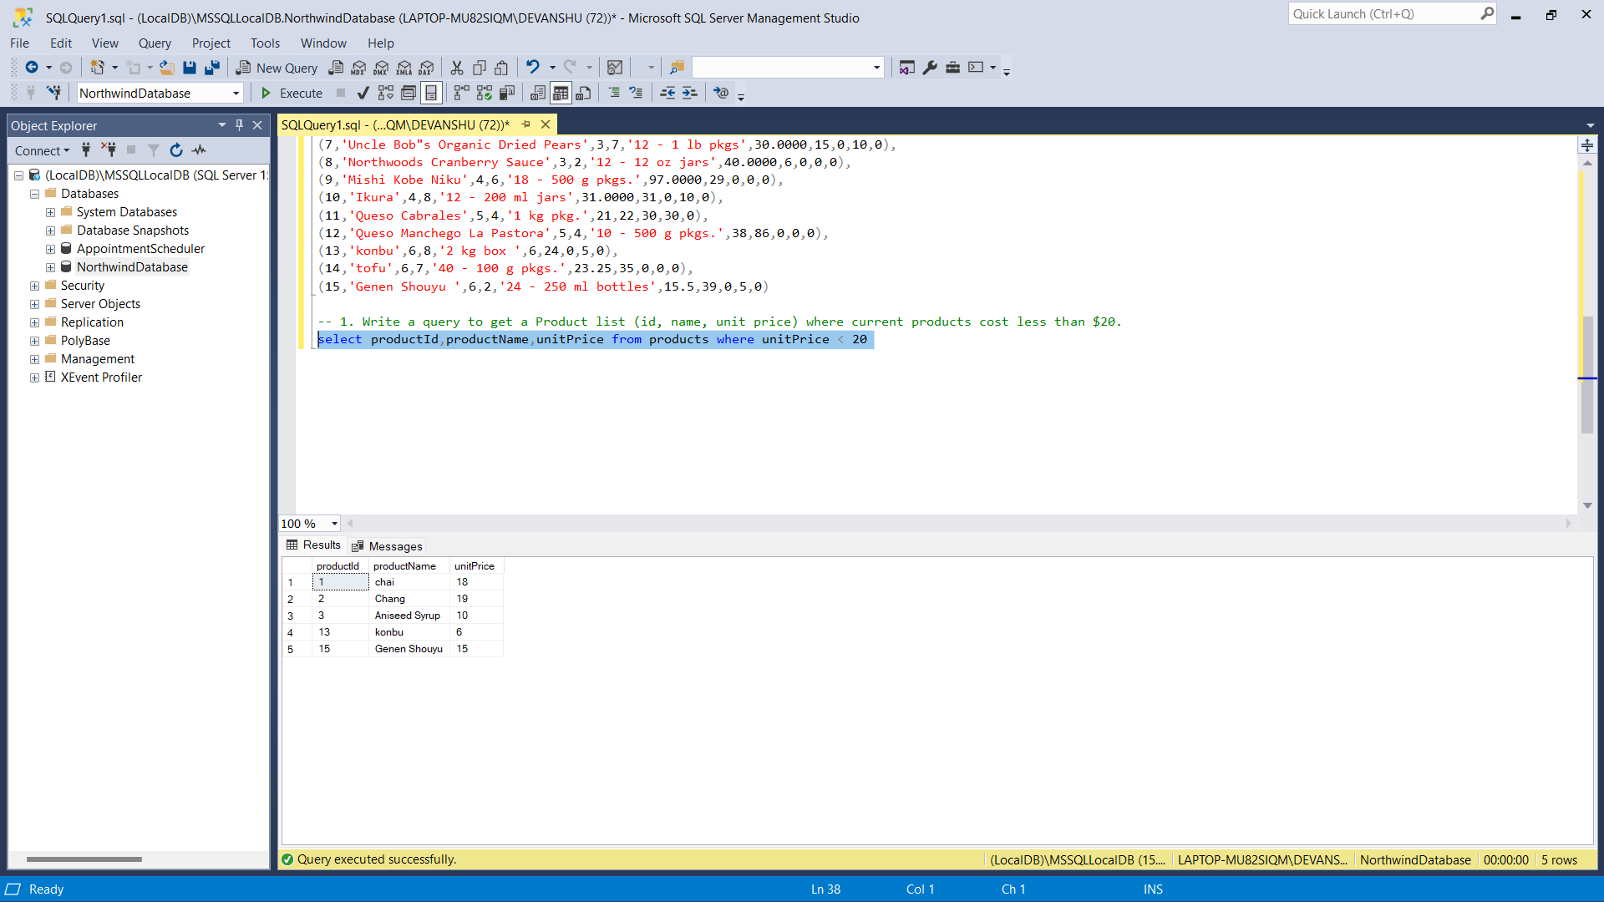

1. Write a query to get Product list (id, name, unit price) where products cost between $15 and $25.

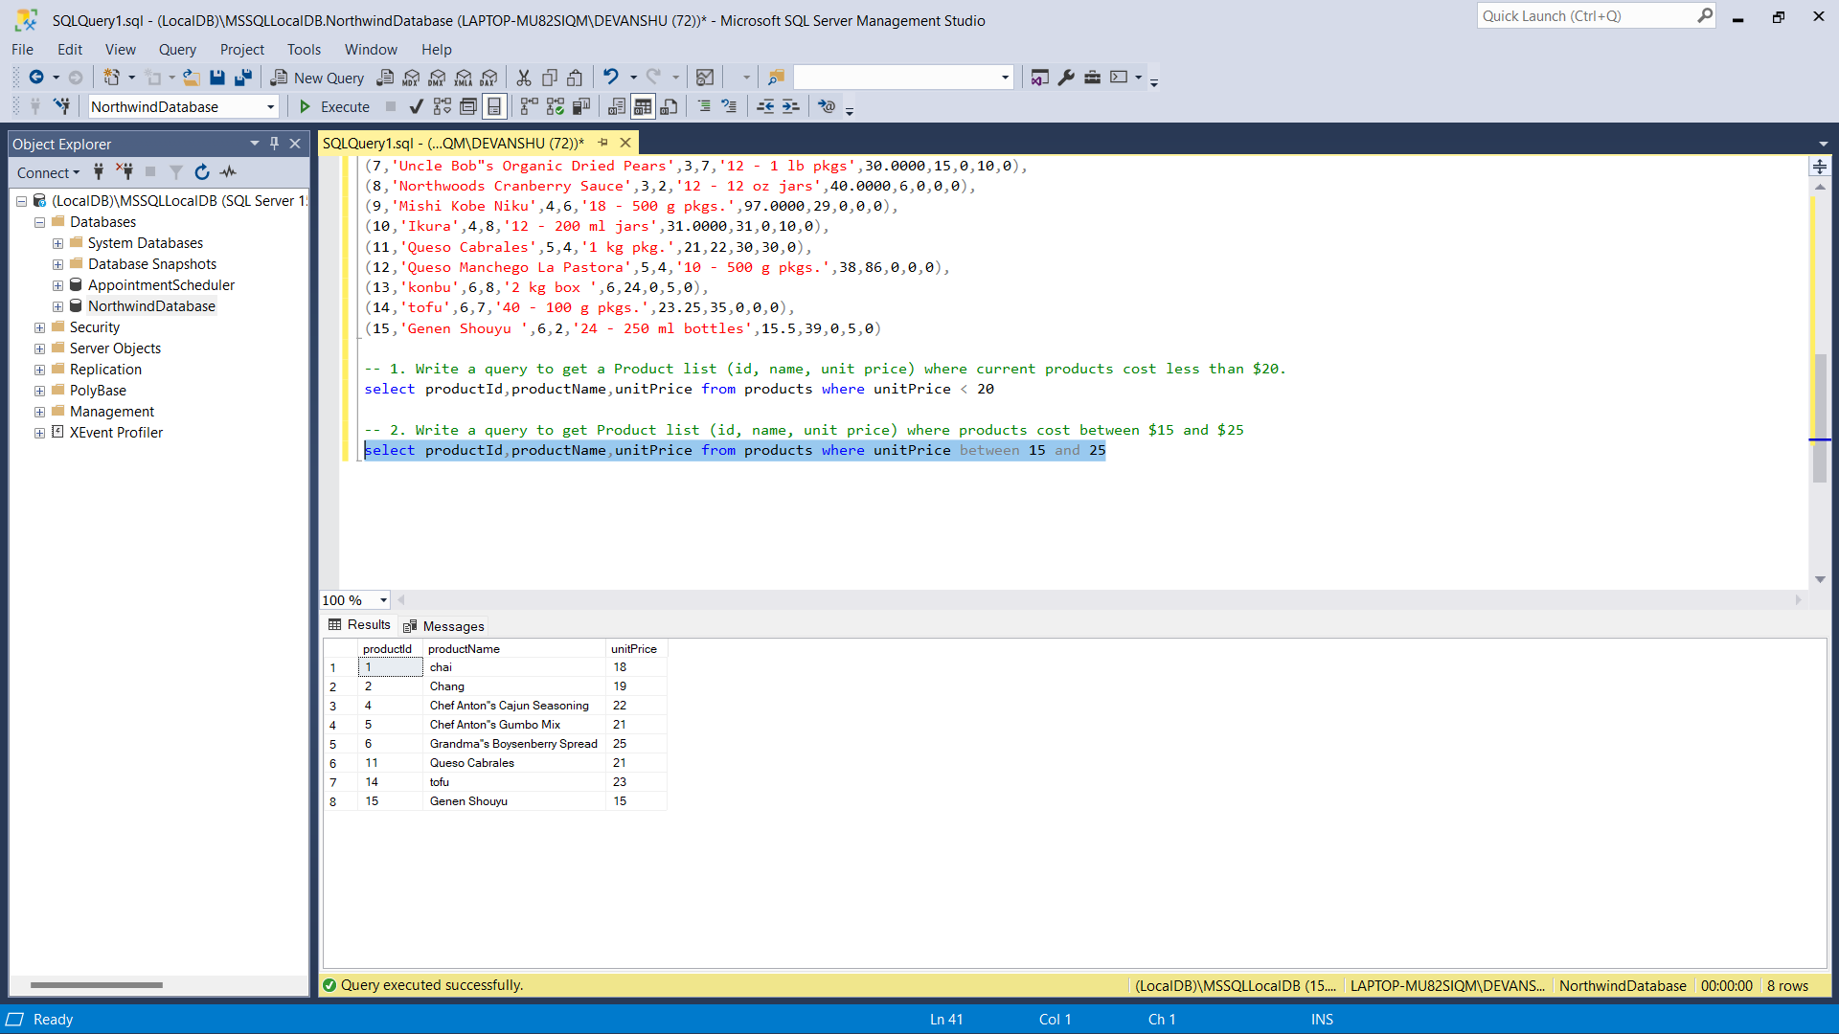

1. Write a query to get Product list (name, unit price) of above average price.

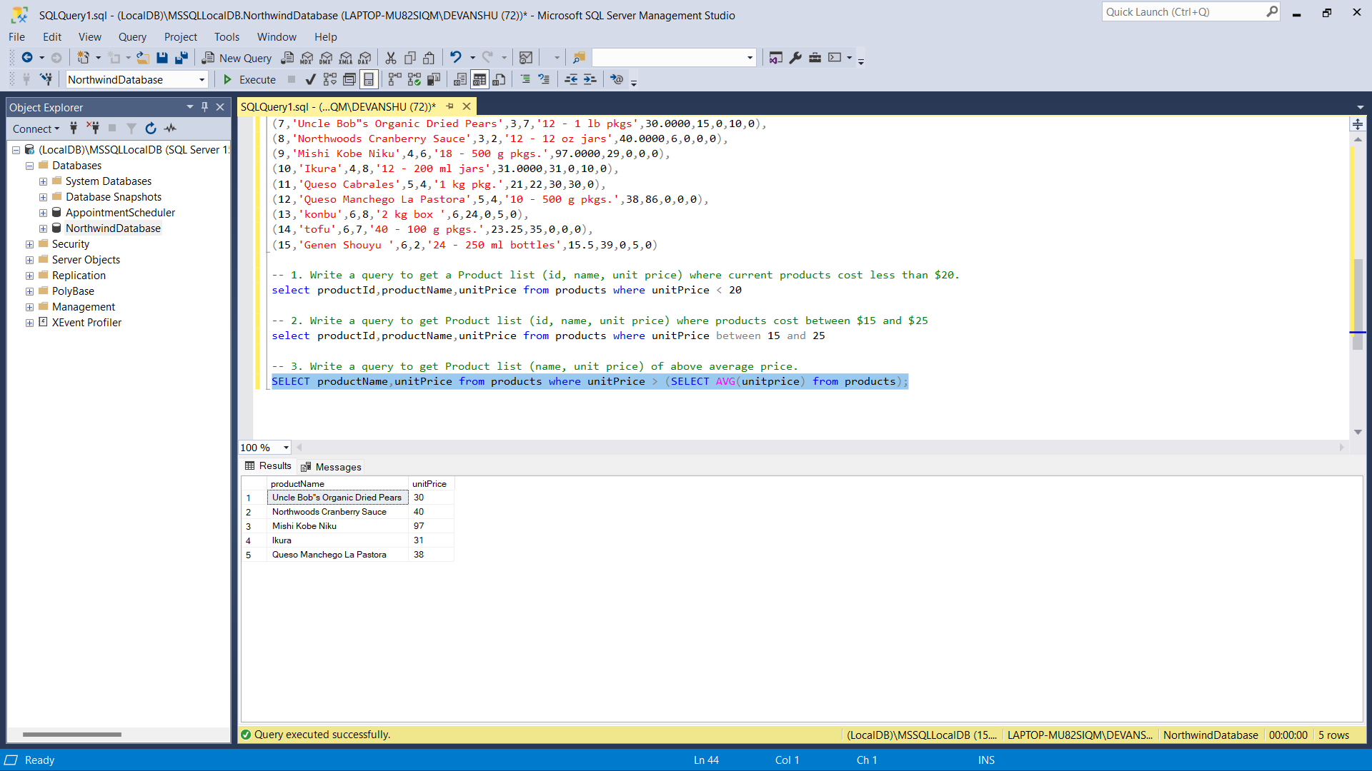

1. Write a query to get Product list (name, unit price) of ten most expensive products.

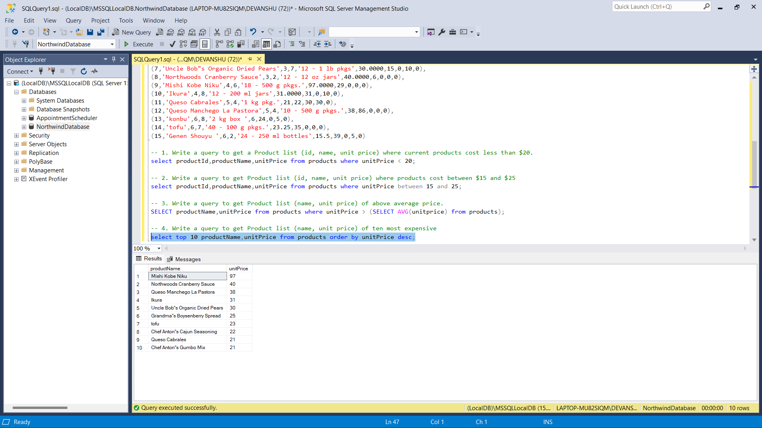

1. Write a query to count current and discontinued products.

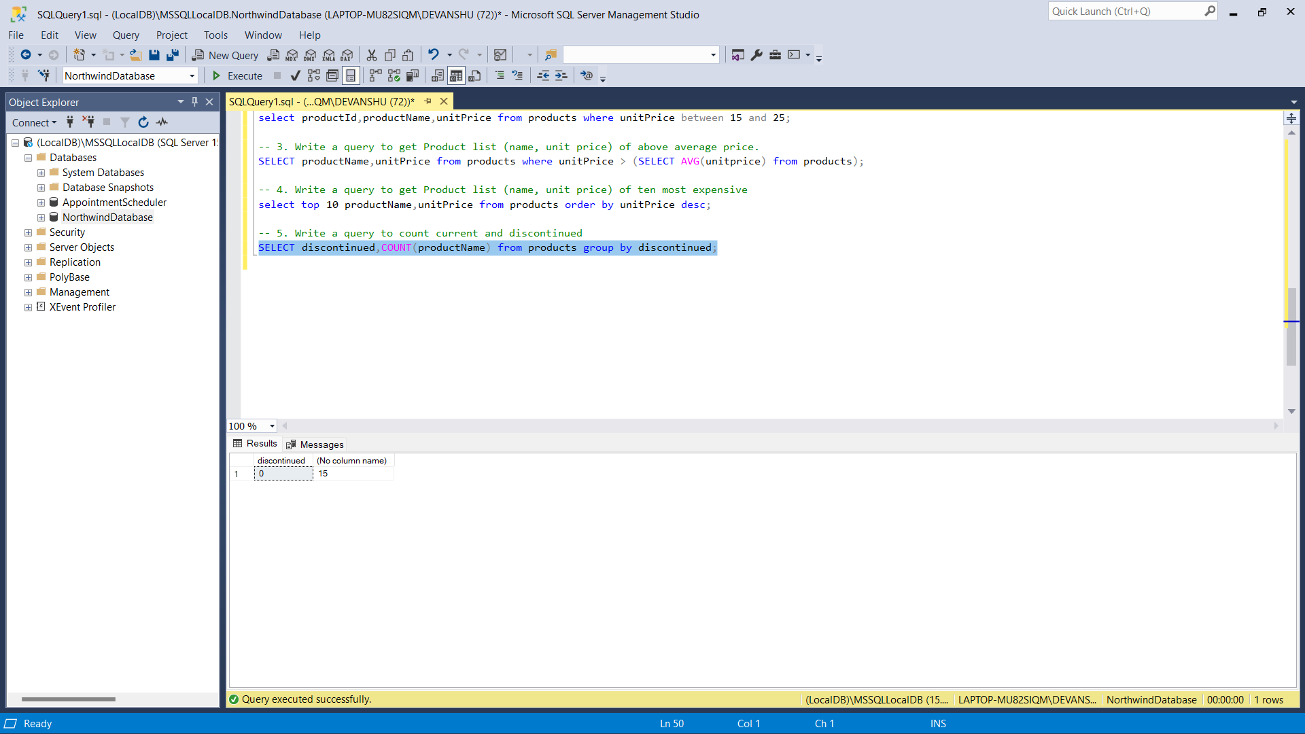

1. Write a query to get Product list (name, units on order , units in stock) of stock is less than the quantity on order.

